

ISSN 2321 3361 © 2021 IJESC

**Research Article**

**Volume 11 Issue No. 03**

Go Green with Digitalized Certificate Generation of Emission Test

P.Deepa1, M.Sonika2, B.Sujeetha3, G.Vaishnavi4 Associate Professor1, UG Scholar 2, 3, 4

Department of CSE, Panimalar Engineering College, Chennai1, 2, 3, 4

# Abstract:

Nowadays, the most common problem faced is that there is a huge increase in pollution.This is because of an increased diesel engine population has created pressures on controlling diesel PM and NOx emissions.Emission standards implemented in 2005 - 2010 timeframe additionally require the use of exhaust after treatment methods on new diesel engines.This is where pollutants such as NOx, CO etc., are created which leads to incomplete oxidation of fuel combustion.To avoid such toxic pollutants,our idea is to develop a system which will be useful to monitor the emission of the vehicle.Firstly, air pollution sensors are used.Then, microcontroller such as AVR are used to process the readings from those sensors and Wi-Fi gateways are used for pushing those data to the database using application program interface.Secondly,a web application will be developed to monitor the abnormal emission of the vehicle and a mobile application will be developed using react native to get abnormal emitting vehicle information.Finally, a certificate will be automatically generated and send through mail. Thus, this paper will be useful to identify the pollution emitting vehicle easily and can control the air pollution.

**Keywor ds:** Emission Standards, Pollution, Digitalized certificate.

# INTRODUCTION

In India there are more than 250 millions transports we are using which emits the toxic gas for best example we come to know in Delhi . Due to emission of gases how people we suffered a lot even to get oxygen .There is an oxygen bank where we take a pure O2 this is the situation existing. Our idea is to automate the existing emission test process.In the existing system, emission test center have to take a proper license from the concerned authority to conduct the test. But there are some loopholes in this system. Main drawback is that when emission test center connect the device to the silencer of vehicle, emission test values which are given as input to the system are used to generate the certificate. But there will be an option to change the values and generate the fake certificate and take the printout there itself. In addition to this, the vehicle owner can give bribe to the person who generate the certificate by adjusting the values. So we want to automate the system in the IOT environment and authorize server and there should be one authority so that, even that authority have no option to change the values. The authority can only see the vehicle and vehicle number at the place where it is tested. At the authority center there would be a person who confirms whether the vehicle pass or fail in emission test. Internally, the values are checked according to the standards based on the type, model and an email of the certificate is sent to vehicle owner and he can download it anywhere, as the certificate is publically available in cloud.

# LITERATURE SURVEY

[1].Title of the paper: A Wireless Sensor Network for Monitoring Environmental Quality in the Manufacturing Industry

Authors: Qilong Han, Peng Liu, Haitao Zhang, Zhipeng Cai Algorithm: Zigbee network.

Advantage: Improved LSTM prediction model. Disadvantage: More Costly.

[2].Title of the paper: Multitask Air-Quality Prediction Based on LSTM-Autoencoder Model.

Authors: Xinghan Xu, Minoru Yoneda. Algorithm: Data- Driven approaches

Advantage: PM2.5 prediction.

Disadvantage: More advance algorithms are available than this.

[3]. Title of the paper: Spatiotemporal Graph Convolution Multifusion Network for Urban Vehicle Emission Prediction Authors: Zhenyl Xu,Yu Kang.

Algorithm: Spatio-temporal Graph Convolution Multifusion Network.

Advantage: The model evaluated on the practical monitoring

data of vehicle emission data in Hefei,and the results demonstrate that our proposed model can predict regional vehicle emissions effectively.

Disadvantage: No real time web application or mobile application to monitor the emission of the vehicles.

[4].Title of the paper: Predictive Control for NOx Emission Reductions in Diesel Engine Vehicle Platoon Application Authors: Yao Ma,Jummin Wang,

Algorithm: A Segmentor Enhanced Network to exploit localized property is been proposed.

Advantage: Predictive control design for diesel vehicle

platoons, such as medium and heavy duty truck platoons,to achieve lower NOx emissions.

Disadvantage: Performance improvements is demonstrated

through simulation studies based.

[5].Title of the paper: Recurrent Air Quality Predictor Based on Meterology and Pollution-Related factors.

Authors: Ke Gu,Junfei Qiao

Algorithm: Recurrent Air Quality predictor (RAQP). Advantage: Air Quality Prediction.

Disadvantage:This algorithm is inefficient.

[6]. Title of the paper: Deep Air Learning: Interpoaltion, Prediction, and Feature Analysis of Fine-grained Air Quality. Authors: Zhongang Qi, Tianchun Wang, Guojie Song, Weisong Hu, Xi Li,zhongfei (Mark) Zhang

Algorithm: Deep Learning Network.

Advantage: Prediction, and feature analysis of fine grained air quality

Disadvantage: Difficult to understand this steps.

# PROPOSED SYSTEM

The IoT-based emission test system produces authentic digital emission test certificates. The objective is to overcome some of the disadvantages of the current emission test system where the sensor values are easily altered in the certificates in order to avoid vehicle servicing overhead in case exceeding the standard emission threshold. The current system of emission test certificate generation requires manually collecting the sensor readings and generating paper-based certificates where the information on the certificate is not ensure. The idea of proposed system is to develop secured mechanism of collecting the sensor readings using

1).MQ2 smoke sensor - avoiding any third party intervention and suitable for detecting H2, LPG, CH4, CO, Alcohol, Smoke or Propane. Due to its high sensitivity and fast response time, measurement can be taken as soon as possible. The sensitivity of the sensor can be adjusted by potentiometer.

2). MQ3 sensor – This sensor has a high sensitivity and fast response time. Sensor provides an along resistive output based on smoke detected and has a good resistance to disturbances due to smoke, vapour and gasoline.

MQTT

Protocol

Gateway Module



Web App

Mobile App

Database Integration

Micro- controller Unit

Air Pollution Sensor

Power Supply

GPS

Module

# Fig 1. BLOCK DIAGRAM

MQ3 alcohol sensor module can be easily interfaced with Microcontrollers, Arduino Boards, and Raspberry Pi etc. The drive circuit is very simple, all it needs is one resistor ADC - A simple interface could be a 0-3.3V ADC.

3).The Arduino Uno is a microcontroller board. It has 14 digital input/output pins (of which 6 can be used as PWM outputs), 6 analog inputs, a 16 MHz crystal oscillator, a USB connection, a power jack, an ICSP header, and a reset button. It contains everything needed to support the microcontroller; simply connect it to a computer with a USB cable or power it with an AC-to-DC adapter or battery to get started. The sensor readings and the vehicle number is encrypted in the Arduino using RSA cryptosystem. The encrypted data is sent

over cloud to the Certificate Authority (CA) for further processing and certificate generation CA ensures the authenticity by comparing thereceived owner details with the one in the CA database. Certificates are generated according to the test results.

# SYSTEM ARCHITECTURE

System will ensure the integrity of collected readings by suitable data encryption and directly sends it to the CA, hence avoiding any kind of manipulation. Since there is no way of altering the sensor readings at the center or at the CA, malpractices in the existing system can be prevented leading to minimizing the pollution in the environment. 1). A regulated power supply of 5v or 12v must ensure the operation of smoke sensor Arduino kit. 2). The Centralized Authority must be able to accept or reject the requests from the emission test centres to authorize them to conduct tests. 3). The entire sensors used for calculate the concentration of gases must be able to transmit the data to centralized authority. 4). The data captured from the sensors should be transferred to the cloud without fail. 5). The centralized authority must be able to accept or reject the request for certificate from client by retrieving values from the cloud storage. 6). Provision should be provided to notify when the traffic authorities feel immediate action is needed for the vehicle causing pollution. 7). The concerned users should receive an email of the test results in the form of pdf. 8). The user should be able to access a web application which gives access to the emission test result of his/her vehicle in the form of pdf stored in cloud for future use.

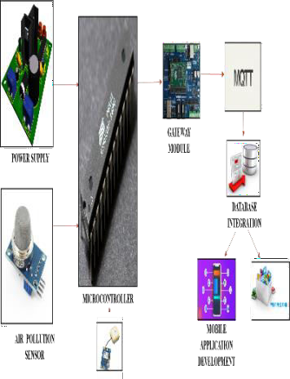

# Fig 2. ARCHITECTURE DIAGRAM

1. **MODULE DESCRIPTION Processing Module**

ATmega-328 (AVR) micro-controller is used to collect the data from the air pollution sensor**.**ATmega-328 is basically an Advanced Virtual RISC (AVR) micro-controller.

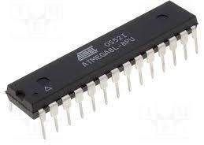

# Fig 3. Processing Module

It supports the data up to eight (8) bits. ATmega-328 has 32KB internal built-in memory. This micro-controller has a lot of other characteristics.

# Gateway Module

The ESP8266 gateway module, which collects the data from the AVR Microcontroller and sends them to the web application wirelessly. The ESP8266 is a low-cost Wi-Fi chip with full TCP/IP stack and MCU (microcontroller unit) capability. The very low price and the fact that there were very few external components on the module which suggested that it could eventually be very inexpensive in volume, attracted many hackers to explore the module.

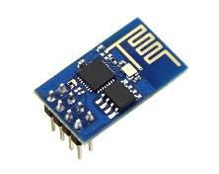

# Fig 4. Gateway Module

The successor to these microcontroller chips is the ESP32. ESP8266 (presently ESP8266EX) is a chip which manufacturers are making wirelessly networkable micro- controller modules.

# Database Integration

MongoDB, an open-source cross-platform document-oriented database program is used for database management.Database is a physical container for collections. Each database gets its own set of files on the file system. A single MongoDB server typically has multiple databases.Collection is a group of MongoDB documents. It is the equivalent of an RDBMS table.A document is a set of key-value pairs. Documents have dynamic schema. Dynamic schema means that documents in the same collection do not need to have the same set of fields or structure, and common fields in a collection's documents may hold different types of data.

# Email Integration

We are using email integration and SMTP protocol.For integrating email we will be using the SMTP protocol which is used for sending and receiving mail as configured by us. In this paper, we are going to send an email via SMTP server. SMTP works by starting a session between the user and server, whereas MTA (Mail Transfer Agent) and MDA (Mail Delivery Agent) provide domain searching and local delivery services.

# Mobile App Developme nt

React Native is a framework that builds a hierarchy of UI components to build the JavaScript code.It has a set of components for both iOS and Android platforms to build a mobile application with a native look and feel. React Native seems to be a viable solution for building high-quality apps in a short time with the same performance and user-experience standards that native apps provide.React Native apps are compiled into natively written code, which enables React Native to not only work on both operating systems, but also have same features on both platforms with no lag.

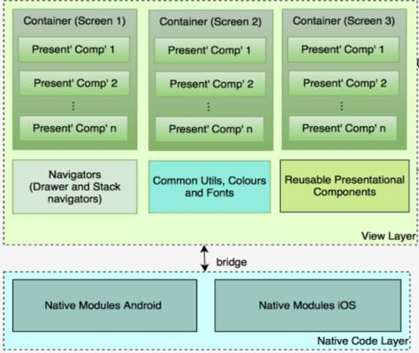

# Fig 5. React Native

1. **SYSTEM IMPLEMENTATION**

The system was implemented using hardwares such as Air Pollution Sensors, GPS, Microcontroller, Wi-Fi Module hardware and softwares such as Visual Studio, Python.

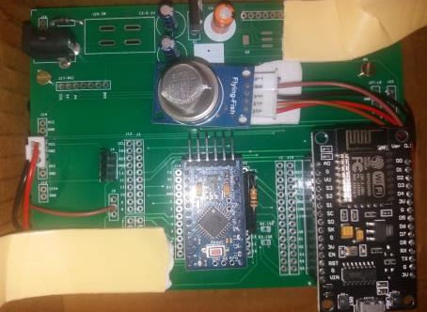

# Fig 6. Hardware Kit for Air Pollution Sensing

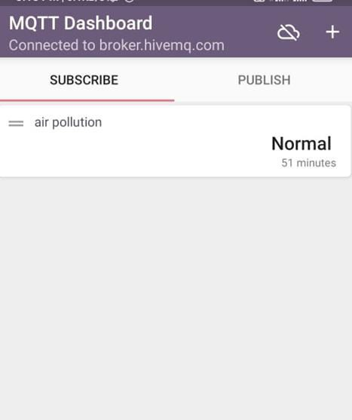

**Fig 7. Vehicle found to be in normal condition**

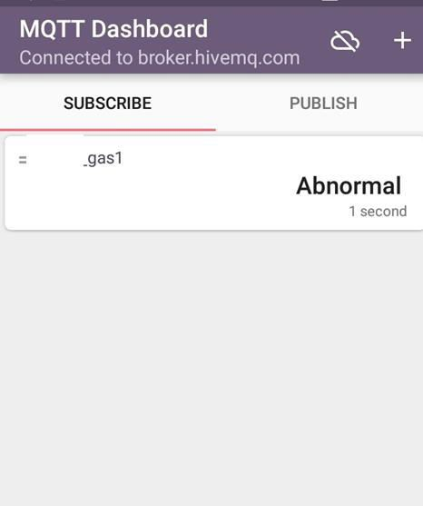

# Fig 8. Vehicle found to be in abnormal condition

1. **CONCLUS ION**

In existing system, manual fraud and bribery may occur. To avoid that, we propose the Go green with digitalized certificate generation of emission tests. To reduce Global Warming, we introduce this system in order to control the disqualified vehicle that runs in our society. Coming to the concept of GO GREEN, our paper will identify the disqualified vehicle and charge them fine by tracking those using GPS.

# REFERENCES

1. An Automatic System for Unconstrained Video -Based Face Recognition, Jingxiao Zheng , Rajeev Ranjan, Ching- Hui Chen , Jun-Cheng Chen, Carlos D. Castillo, and Rama Chellappa
2. Predictive Control for NOx Emission Reductions in Diesel Engine Vehicle Platoon Application [2019, Vol No: 2168- 2291]
3. QILONG HAN 1, PENG LIU 1, HAITAO ZHANG1, AND ZHIPENG CAI 2, (Member, IEEE) 1College of Computer Science and Technology, Harbin Engineering University, Harbin 150001, China “A Wireless Sensor Network for Monitoring Environmental Quality in the Manufacturing Industry” Received May 9, 2019, accepted May 27, 2019, date of publication June 5, 2019, date of current version June 27, 2019.
4. Xinghan Xu and Minoru Yoneda “Multitask Air-Quality Prediction Based on LSTM-Autoencoder Model” IEEE Transactions on Cybernetics.
5. Ke GU, Junfei Qiao, Member, IEEE, and Weisi Lin, Fellow, IEEE “Recurrent Air Quality Predictor Based on Meteorology- and Pollution-Related Factors” IEEE Transactions on Industrial Informatics.
6. Zhongang Qi, Tianchun Wang, Guojie Song, Weisong Hu, Xi Li, Zhongfei (Mark) Zhang “Deep Air Learning: Interpolation, Prediction, and Feature Analysis of Fine- grained Air Quality” IEEE Transactions on Knowledge and Data Engineering.